Now it’s coffee, now it’s code.

DEFINITIVE EDITION

Shaun McAlister

Game Engines 1 re-sit

# Task 2

LO2: Prepare workspace and assets for game development. Prepare the necessary design documentation to help guide your development and set up your Unity project. Any art assets you intend to use should be downloaded or produced before the start of Task 3.

1. Design brief
   1. The target device (incl. screen resolution, input methods)

Desktop.

* 1. Controls methods and game mechanics

WASD to move, camera is fixed in place, player uses W to move up the game S to back up when needed and A + D to navigate around obstacles, the camera is blinded to the player with a set offset, the player is sent back to a check point when they hit a red object and nothing happens when they hit a blue object, a player cannot pass though blue objects.

* 1. Game screens
     1. Start screen.
     2. How to play Screen
     3. Game screen
     4. Pause menu. (can be an on off switch)
     5. Win screen
  2. Gameplay flowcharts

Reach the end goal, when a player passes over a check point their respawn point is moved to that check point, if a player dies, they go back to the checkpoint.

* 1. Game objectives

Get to the end of the track while avoiding obstacles,

* 1. Art assets (2D / 3D)
  2. User Interface outlines

1. GitHub repository

https://github.com/MrMcAlister97/Game-Engines-Resit

1. Art Asset

Images used:



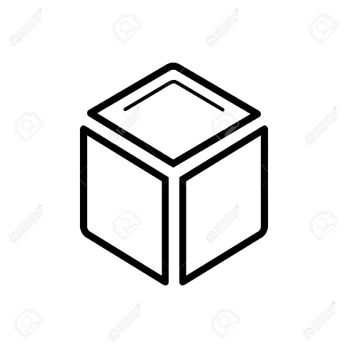

Music used:

Main menu : <https://www.youtube.com/watch?v=VH8mQRXemuo&t=5s>

In game: <https://www.youtube.com/watch?v=Wx2FDyvt0gI>